Aim:
To implementation and time analysis of Merge sort
Algorithm:
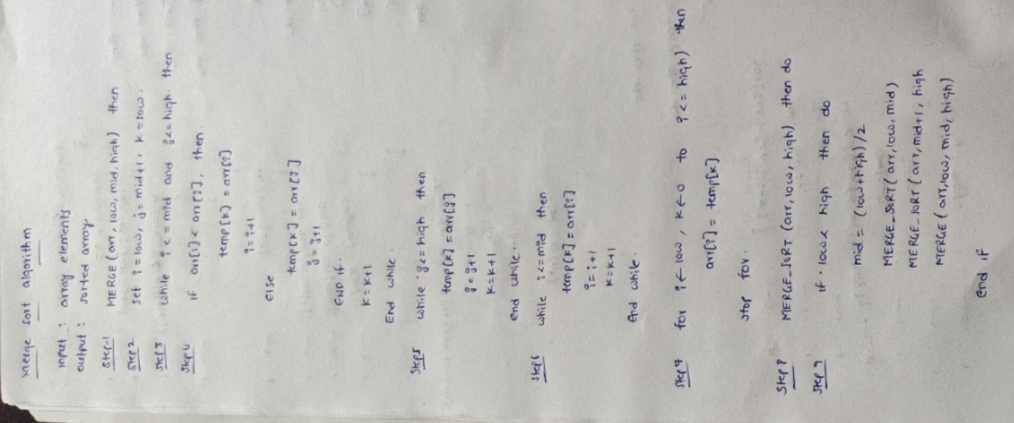

Code:

#include <iostream>
using namespace std;
void merge(int arr[], int low, int mid, int high) {
int i = low;
int j = mid + 1;
int k = 0;
int temp[high - low + 1];
while (i <= mid && j <= high) {
if (arr[i] < arr[j]) {
temp[k] = arr[i];
i++;
}
else {
temp[k] = arr[j];
j++;
}
k++;
}
while (i <= mid) {
temp[k] = arr[i];
i++;
k++;
}
while (j <= high) {
temp[k] = arr[j];
j++;
k++;
}
for (int i = low, k = 0; i <= high; i++, k++) {
arr[i] = temp[k];
}
}
void mergeSort(int arr[], int low, int high) {
if (low < high) {
int mid = (low + high) / 2;
mergeSort(arr, low, mid);
mergeSort(arr, mid + 1, high);
merge(arr, low, mid, high);
}
}
int main() {
int n;
cout << "Enter number of elements: ";
cin >> n;
int arr[n];
cout << "Enter " << n << " elements: ";
for (int i = 0; i < n; i++) {
cin >> arr[i];
}
mergeSort(arr, 0, n - 1);
cout << "Sorted array: ";
for (int i = 0; i < n; i++) {
cout << arr[i] << " ";
}
return 0;
}

Output:
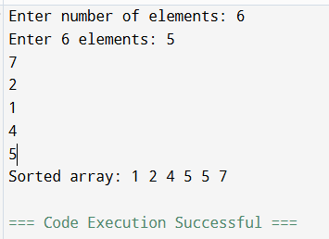

Time complexity:

